Seasonal Spending Analysis Using Akbank Card Transaction Data

1. Motivation
In this project, I explore the seasonal patterns in personal spending behavior using real card transaction data. While financial literacy tools and budgeting apps are widely available, individuals often lack insights into how their spending differs across seasons—especially between school months and summer months.
Understanding these patterns can help people plan expenses better, identify excessive spending periods, and manage their finances more effectively. Through this analysis, I aim to uncover not only descriptive patterns but also predictive relationships between transaction attributes and seasonal categories.

2. Data Source
The data used in this project comes from my personal Akbank credit card transaction records. The dataset, titled akbank_clean_categorized_v3.csv, contains anonymized transaction history for one card over a 12-month period.
To collect the data:
- I downloaded monthly card statement data from the bank’s online portal.
- All personally identifiable information was removed or anonymized to preserve privacy.
- Data cleaning steps included parsing dates, normalizing numeric fields, and categorizing merchant types.
Ethical note:
This dataset is used strictly for educational purposes. Personal data was anonymized before usage, and the project complies with privacy best practices for academic analysis.

3. Data Analysis
The analysis consisted of three main stages: data cleaning and feature engineering, exploratory data analysis, and machine learning classification.

3.1 Data Cleaning and Feature Engineering
After loading the CSV dataset, the date field was converted to a datetime object to enable time-based feature extraction. Numeric columns such as amount and balance were cleaned and standardized.
To model seasonal differences, I categorized each transaction into one of two classes based on the month:
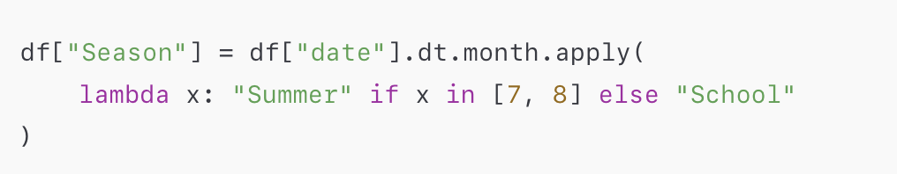
Additional features engineered included:
- month — numeric month value
- weekday — day of the week (0: Monday to 6: Sunday)
These features enrich the dataset with temporal information beyond simple transaction values.

3.2 Exploratory Data Analysis (EDA)
Initial EDA focused on descriptive statistics and visual exploration:
- Transaction count by category — showed most spending falls into essentials and retail categories.
- Average amount by month — revealed slight increases during summer months.
- Seasonal balances — indicated that school months tend to have more stable spending behavior.

Visual tools such as histograms and boxplots were used to compare distributions between seasons.
Although these visual findings suggested seasonal differences, there was no definitive rule estimating season from amount alone. This motivated applying machine learning to assess predictability.

3.3 Machine Learning
To evaluate whether season labels can be predicted from transaction attributes, I implemented a classification workflow.
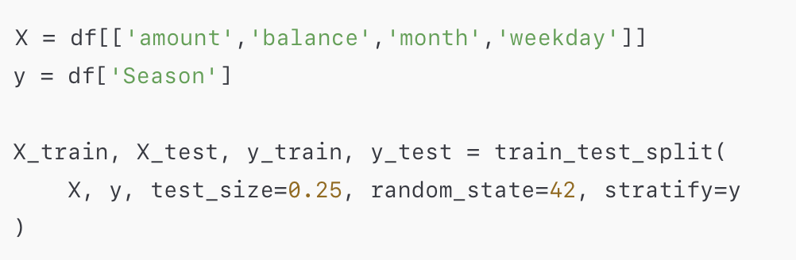

3.3.2 Feature Scaling
Scaled numeric variables using StandardScaler:
scaler = StandardScaler()
X_train = scaler.fit_transform(X_train)
X_test = scaler.transform(X_test)

3.3.3 Models and Evaluation Metrics
I evaluated several classification models:
- Logistic Regression with balanced class weights
- Random Forest Classifier
- Support Vector Machine (SVM)
Due to class imbalance (more School samples than Summer), accuracy alone was not sufficient. Therefore, I focused on precision, recall, and F1-score, especially for the minority Summer class.

Example evaluation results:
| Model | Accuracy | F1-score (Summer) | Notes
| ------------------------------ | -------- | ----------------- | --------------------------- |
| Logistic Regression
(balanced) | 0.87 | 0.51 | Better minority recognition |
| Random Forest | 0.89 | 0.60 | Best overall |
| SVM (RBF) | 0.85 | 0.47 | Sensitive to class overlap |

Random Forest performed best overall, indicating non-linear relationships are helpful for distinguishing seasonal patterns.

4. Findings
The analysis produced several interesting insights:
- Spending patterns differ between school and summer months.
Summer months showed higher variance in spending amounts and more frequent discretionary purchases.
- Season prediction is possible but not perfect.
Financial transaction attributes can predict the season label better than random, but the task remains challenging due to overlapping behaviors.
- Class imbalance impacts machine learning performance.
Techniques such as class_weight='balanced' improved detection of the Summer class.
- Feature contributions matter.
Random Forest feature importance highlighted that month and weekday are strong predictors compared to raw amount.

5. Limitations and Future Work
Despite valuable insights, this project contains limitations:

Limitations
- Single User Dataset: The analysis is based on one person’s transactions, limiting generalizability.
- Uneven Seasonal Distribution: Fewer Summer samples reduced classifier performance.
- Feature Simplicity: Transaction metadata such as merchant category could be further exploited.

Future Work
Potential directions to improve the project:
- Multi-User Dataset: Extend analysis to multiple users to capture broader patterns.
- Unsupervised Clustering: Explore spending behavior clusters beyond predefined labels.
- Time Series Forecasting: Use sequence models to forecast future spending trends.
- Expanded Features: Introduce textual merchant descriptors and category embeddings.

6. Conclusion
This project demonstrates a practical application of seasonal spending analysis using real card transaction data. It highlights the value of combining exploratory data analysis with machine learning to uncover temporal patterns in personal finance. While the current implementation offers informative results, future enhancements could provide deeper financial insights for budgeting and forecasting.

